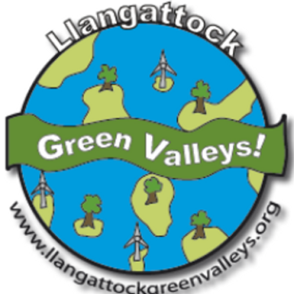**Llangattock Green Valleys newsletter**

Issue 84

July 2017

*http://www.llangattockgreenvalleys.org/*

**ENERGY GENERATION PROJECTS:**

By Steve Sharp

**Hydro - MH-1 and MH-2 updates**:

We have had some short periods of rain but the weather has been warm and dry and so there has been very little generation at Nant yr Hafod (MH-2) and none at Cwm Gu (MH-1) this last month.

Because of the lack of rain, TGVH has been unable to start flow gauging at Cwm Gu to gather the further data requested by NRW to support our HoF notch application. The low water levels have also brought to our attention a small hole at the intake of Cwm Gu and so we have asked TGVH to repair this as soon as possible.

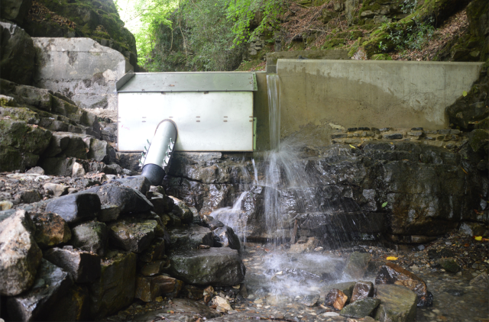Construction of our latest MH-2 Blaen Dyar scheme is nearing completion. The regional electricity operator Western Power has carried out their major works and we are now waiting for EoN to change the meter from single to split phase and reposition it in the new kiosk. The turbine house is almost complete and we are arranging a date for final testing of the scheme.

We are also in discussions with Western Power about Abernant and Cwm Saerbren, our two remaining MH-2 schemes which will be built before the end of the year. *Image: Intake point at Blaen Dyar by Penny Hallas*

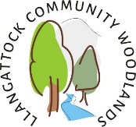**Contemplation Corner and Bee Palace**

By Jackie Charlton and Bob Needs

It’s been a very busy month getting the land sorted at the Alder Carr woodland with contractors completing the final elements of our development. We started in September 2016 to work in this beautiful meadow and woodland and can now see that the hard work has been so worthwhile. The meadow has been cut to hay and this will provide a good source of feed for a local farmer.

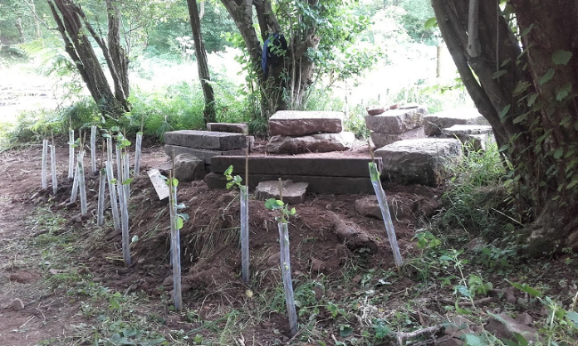The Contemplation Corner will create a wonderful space to be still and quiet and enjoy the surroundings. We are hoping that groups that want to spend time outside or just to be together will use this space in the future. It could be a great area for artists or Welsh conversation groups, so if you are interested in coming along to see what is available for your group, please do contact us.

The foundation is ready to take on our ‘Bee Palace’ - a grand name for our observation shelter and store. We are providing full access for anyone who wants to view bees in safety with the door wide enough to take a wheelchair. The meadow and woodland has lots of flat areas to aid accessibility, so we are hoping to encourage as many people as possible to come and view our lovely bees. Watch this space for completion of the Bee Palace.

On clearing the area we have come across nesting wrens which we saved and the chicks have now fledged, along with several frogs and toads who have been carefully placed into a wet area in the hope that they will flourish and return to spawn next year. It’s amazing what gems you find in a small space as diverse as our woodland and meadow. We hope to start recording information in a more evidence-based way but at present we just enjoy the moment.

**New Website Launch**

We are almost there! Just a few glitches to sort out now and we need to approve the information which will be the backdrop for the website. It is looking really good and should be ready to go live in a couple of weeks, although our volunteers have already had a preview. We will give out the new address next month for certain.

**ALDER CARR LOTTERY**

**Llangattock Community Woodlands** has been advertising the Alder Carr Lottery for several months now and would really like to see more members. For more information, please contact [jackiecharltonlgv@gmail.com](mailto:jackiecharltonlgv@gmail.com) or [andrewgpeach@gmail.com](mailto:andrewgpeach@gmail.com).

The **Alder Carr Lottery** is registered under the Gambling Act 2005 and has a Small Society Lotteries Registration Certificate Registration No: LN/201600367

Woodland Charter new project ideas are on the way from the Woodland Trust.

Bob’s bee notes July

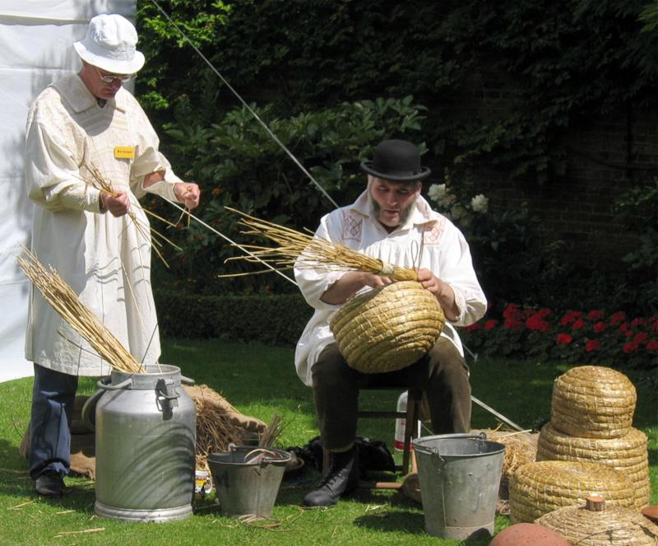A swarm in July isn’t worth a fly. This saying has come about because swarms at this time of year rarely have time to build up enough brood combs on a new site before the weather cools in autumn. The Queen would still need to lay enough eggs to see her through the winter and there would not be enough honey stored and certainly none for the beekeeper. In this situation the old Queen would be removed from the swarm and the bees united to a small colony headed by a new young Queen. In the days of [skep beekeeping](http://beespoke.info/2013/10/22/skep-history/) (round straw hives), strong colonies would be killed off and the wax and honey harvested while the small colonies would be united together. Average size colonies would be allowed to go through the winter without any interference.

In last month’s notes I mentioned that we would need to keep an eye on one of the colonies at the Alder Carr where the Llangattock woodland group meet. The following Tuesday, as I was getting out of my truck in the field next to the bee hives, I could hear the unmistakable sound of bees swarming from that hive. The swarm settled high up in a tree near to the hives but was gone within an hour, before we could do anything about it. You win some and you lose some. One good thing about having a wild swarm in the area is that the drones from that swarm, should it survive, will be carrying a survival gene that could then be passed on to other Queens in the future.

Honey is coming into the hives now and is being stored in the supers (honey boxes), so, if this good weather continues for a few more weeks, we should be getting honey again this year. I have still to look to see how the ling heather plants are growing on the mountain, as that will also give a good late honey crop if we get rain in early August followed by a warm spell later in August and September.

Good beekeeping.

Bee Bob

LCW Trustees are justly proud of the commitment and enthusiasm of all our volunteers. We meet regularly, every Tuesday.

If you are interested in environmental management, green wood crafts or bee keeping then please do get in touch by emailing Eric Gower [eric.gower@gmail.com](mailto:eric.gower@gmail.com) for a membership form.

**LACAS Community Working Party**

Recently the allotmenteers got together to work a lot … and party a little bit.

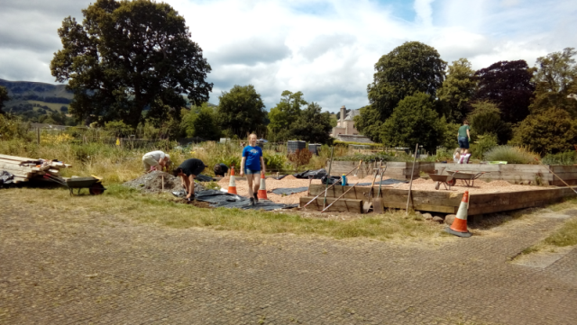The main focus of the work party involved laying the foundations for the community/picnic area on the right as you come into the allotment field. A ramp for wheelchair access to the raised beds and community area was also constructed. All of this involved the positioning and fixing of heavy railway sleepers, clearing the ground and the shifting and spreading of ten tons of

*Image: Community area in the making* clear stones.

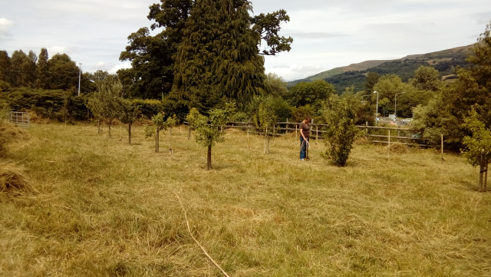The orchard was inspected and we were pleased to see that about half of the grafted potential trees have taken. We can try again next year with those where only the rootstock was successful. Stones were removed to the field edge to permit mowing and strimmers made short work of the long grass. In time we are hoping to establish a wildlife border around the edges of the orchard field. *Image: The Orchard*

Under the shade of the oak tree, our labours were rewarded with a selection of tasty goodies off the barbecue and maybe just a sip or two of cider to wash it down. Huge thanks are due to all of those (11 of us on one day, 17 on the other) who put in their time and effort to improve the Llangattock allotment site and help in its upkeep.

***Date for the diary:*** *LACAS Show Saturday 9th September*

For any LACAS queries, do contact Phil Gibson on 01873 811537 or [gibsons@uwclub.net](mailto:gibsons@uwclub.net)

**LGV VOLUNTEERS NEEDED PLEASE! CAN YOU HELP?**

We are looking for a number of people who would like to get involved at Director and non-Director level. Please get in touch with Andrew Fryer if you would like to explore the ways in which you can help: [andrewfryer70@gmail.com](mailto:andrewfryer70@gmail.com)

You can meet our Board of Directors[here](http://www.llangattockgreenvalleys.org/about-lgv/the-board-of-directors/)**.**

**PLEASE ASK US!**

If anybody would like to look at LGV’s finances or discuss our schemes, please contact us and we will be very happy to help. We are proud to be operating a transparent and successful Community Interest Company.

You may also find useful answers to our [frequently asked questions](http://www.llangattockgreenvalleys.org/faqs/) on the LGV website.

**To find out more about us or to become a member, please visit:**

[**www.llangattockgreenvalleys.org**](http://www.llangattockgreenvalleys.org)

**Follow us on Twitter! @LGVcic and**

**Like and share our** [**LGV Facebook Page**](https://www.facebook.com/LlangattockGreenValleys/?ref=aymt_homepage_panel)